**Perform parsing of family tree using knowledge-base**

**1. Introduction to Family Tree Parsing**

Family trees represent relationships among individuals, typically showcasing generational ties like parent-child and sibling relationships. Parsing a family tree involves interpreting and extracting information from such a structure to answer queries like "Who is X's parent?" or "How are X and Y related?"

Using a knowledge base (KB) to represent a family tree allows for efficient querying and reasoning about relationships. A knowledge base stores facts about individuals and their relationships, and reasoning engines can infer new facts from existing ones.

**2. Understanding a Knowledge Base**

A knowledge base (KB) is a collection of structured information that can be used to store and retrieve facts about a domain. In the context of a family tree, the KB stores relationships (e.g., parent, sibling, child) and personal details (e.g., name, age, gender).

**Components of a Knowledge Base:**

* **Facts**: Pieces of information, such as "Alice is Bob’s mother."
* **Rules**: Logical implications, such as "If X is the parent of Y, then Y is the child of X."
* **Queries**: Questions that can be asked of the knowledge base, such as "Who are Bob’s siblings?"

**3. Components of a Family Tree**

A family tree consists of individuals and their relationships:

* **Individual nodes**: Each person is represented as a node.
* **Edges (relationships)**: Parent-child, sibling, and spousal relationships are represented by edges between nodes.

**Common relationships:**

* **Parent/Child**: A direct vertical link from one generation to the next.
* **Siblings**: Individuals with common parents.
* **Grandparent/Grandchild**: Indirect generational links.
* **Cousins**: Individuals who share common grandparents.

**4. Steps to Build a Knowledge Base for a Family Tree**

1. **Define Entities (Individuals)**
   * Each person is an entity in the knowledge base, identified by attributes like name and gender.
   * Example:
     + Person(Alice)
     + Person(Bob)
2. **Define Relationships**
   * Relationships are captured as facts within the KB, such as parent_of(Alice, Bob) to denote that Alice is Bob's parent.
   * Other relationships: sibling_of, grandparent_of, etc.
3. **Apply Rules for Inference**
   * Rules can be applied to infer relationships. For instance, a sibling rule:

sibling_of(X, Y) :- parent_of(Z, X), parent_of(Z, Y), X ≠ Y

* + This rule means X and Y are siblings if they share a common parent Z.

**5. Parsing Techniques for Family Trees**

**Parsing** in this context involves interpreting the relationships within a family tree and building a structured representation. Some common techniques include:

* **Recursive Parsing**: Family trees are naturally hierarchical, making recursion a suitable method for parsing. Each individual can recursively link to their parent and children.
* **Graph Parsing**: Family trees can be represented as graphs, where nodes are people and edges are relationships. Graph traversal techniques like Depth-First Search (DFS) can be used to explore relationships.

**6. Example: Family Tree Parsing**

Let’s consider a simple family tree:

markdown

John

/ \

Alice Bob

|

Carol

**Knowledge Base Representation:**

* **Facts**:
  + parent_of(John, Alice)
  + parent_of(John, Bob)
  + parent_of(Alice, Carol)
* **Rules**:
  + child_of(Y, X) :- parent_of(X, Y)
  + sibling_of(X, Y) :- parent_of(Z, X), parent_of(Z, Y), X ≠ Y

**Querying:**

* **Query 1**: Who is Alice’s parent?
  + parent_of(John, Alice)
  + **Answer**: John.
* **Query 2**: Does Alice have any siblings?
  + Apply the sibling_of rule to find that sibling_of(Alice, Bob) is true.
  + **Answer**: Bob.
* **Query 3**: Who are Carol’s grandparents?
  + Apply parent_of(Alice, Carol) and parent_of(John, Alice) to infer that John is Carol’s grandparent.
  + **Answer**: John.

**7. Inference and Querying in a Knowledge Base**

Inference in a knowledge base allows us to derive new facts from existing ones using predefined rules. For example:

* Given parent_of(John, Alice) and parent_of(Alice, Carol), we can infer that John is Carol’s grandparent using the rule:

grandparent_of(X, Z) :- parent_of(X, Y), parent_of(Y, Z)

**Querying** involves asking questions about relationships. For instance:

* **Who are Alice’s children?**: This can be answered by querying child_of(X, Alice).

**8. Diagram**

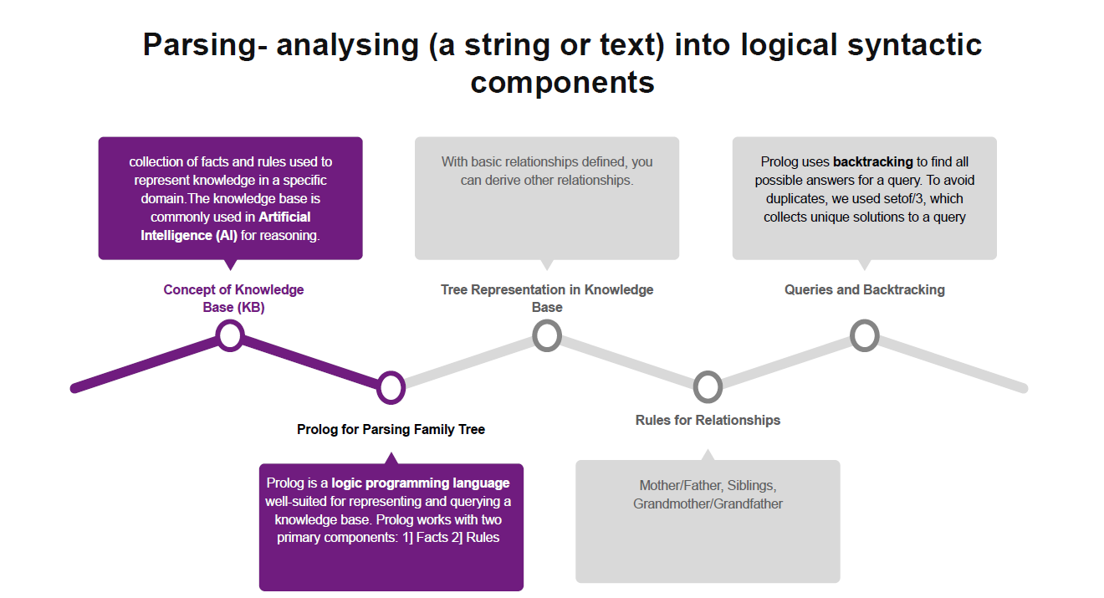**8. 9. Applications of Family Tree Parsing**

* **Genealogy Research**: Family tree parsing is widely used to track ancestry and hereditary information.
* **Medical History Tracking**: Family relationships can be important in identifying inherited medical conditions.
* **AI and Chatbots**: Knowledge bases can be used in AI systems to answer questions about family relationships.

**10. Conclusion**

Parsing family trees using a knowledge base is an efficient way to represent and infer relationships. By defining individuals, relationships, and rules, a family tree can be queried to provide insights into lineage, sibling relationships, and generational ties. This method has broad applications in genealogy, AI systems, and automated family history tools.